SOFTWARE ENGINEERING PROJECT DOCUMENTATION TEMPLATE

RATIONALE
This documentation template is designed to help you complete Component A – Project Documentation of your Software Engineering Year 12 Personal Project.
The template supports the four required stages from the syllabus:
- Identifying and Defining
- Research and Planning
- Producing and Implementing
- Testing and Evaluating
It also includes essential modelling tools (which are EXAMINABLE in the HSC!):
- Context Diagram
- Data Flow Diagrams (DFDs)
- Structure Chart
- IPO Chart
- Data Dictionary
- UML Class Diagram (if OOP)

TITLE PAGE
Project Title: MyCNN
Student Name: Ronen Gupta
Date:
- Start – (02/03/26)
- End – (??/??/??)
Course: Software Engineering Stage 6
GitHub URL (if applicable):

Table of Contents
SOFTWARE ENGINEERING PROJECT DOCUMENTATION TEMPLATE 1
RATIONALE 1
TITLE PAGE 2
Syllabus Requirements 5
1. Identifying and Defining 7
1.1 Problem Statement 7
1.2 Project Purpose and Boundaries 7
1.3 Stakeholder Requirements 7
1.4 Functional Requirements 7
1.5 Non-Functional Requirements 7
1.6 Constraints 7
1.7 Requirements Analysis and Prioritisation 8
2. Research and Planning 9
2.1 Development Methodology 9
2.2 Tools and Technologies 9
2.3 Gantt Chart / Timeline 9
2.4 Communication Plan 9
2.5 Resource Allocation Justification 9
3. System Design 10
3.1 Context Diagram 10
3.2 Data Flow Diagrams (Level 0 and Level 1) 10
3.3 Structure Chart 10
3.4 IPO Chart 10
3.5 Data Dictionary 10
3.6 UML Class Diagram (if OOP) 10
4. Producing and Implementing 11
4.1 Development Process 11
4.2 Key Features Developed 11
4.2.1 Back-End Engineering Contribution 11
4.3 Screenshots of Interface 11
4.4 Version Control Summary (Optional) 11
5. Testing and Evaluation 12
5.1 Testing Methods Used 12
5.2 Test Cases and Results 12
5.3 Evaluation Against Requirements 12
5.4 Improvements and Future Development 12
6. Feedback, Security and Reflection 13
6.1 Summary of Client or Peer Feedback 13
6.2 Secure Software Design and Data Handling 13
6.3 Personal Reflection 13
7. Appendices 14

Syllabus Requirements
Syllabus Requirement | Template Section | STATUS
Identifying problem, feasibility, and requirements | Section 1.1 – 1.6 | *tick*
Stakeholder and client expectations and feedback | Section 1.3, Section 6.1 | *tick*
Functional and non-functional requirements | Section 1.4, 1.5 | *tick*
Project constraints | Section 1.6 | *tick*
Planning methodology and Gantt chart | Section 2.1 – 2.3 | *tick*
Tools and language justification | Section 2.2 | *tick*
Communication with clients and feedback loops | Section 2.4, 6.1 | *tick*
Context Diagram and DFDs | Section 3.1, 3.2 | *tick*
Structure Chart and IPO | Section 3.3, 3.4 | *tick*
Data Dictionary | Section 3.5 | *tick*
UML Class Diagram (if applicable) | Section 3.6 | *tick*
Code implementation and key features | Section 4.1 – 4.2 | *tick*
UI screenshots and explanation | Section 4.3 | *tick*
Version control and iterations (optional) | Section 4.4 | *tick*
Testing methods and test cases | Section 5.1 – 5.2 | *tick*
Evaluation of requirements and software effectiveness | Section 5.3 | *tick*
Suggestions for improvement and future development | Section 6.1 - 6.3
Analyse and respond to feedback,  evaluate the effectiveness of a software solution | Section 6.2

1. Identifying and Defining

1.1 Problem Statement
Many industries face the issue of developing CNN tools at an affordable price to carry out certain tasks (e.g. In the medical industry, doctors may need to differentiate similar looking medicine via properties such as color). This project addresses the need for an accessible alternative in creating CNN solutions that encourage smaller enterprises and larger industries to proactively integrate AI solutions in prevailing issues.

1.2 Project Purpose and Boundaries
The goal is to create an accessible platform which allows for industry professionals needless of coding experience to create CNN tools/models for purposes such as classification, multi-class classification. Users will be able to view metrics of their models such as loss, accuracy, precision, recall, a confusion matrix, and a loss curve in real time, as well as customize hyperparameters such as batch size, learning rate, epochs, train test split, with detailed definitions of those given to users to ensure information pertaining to the training parameters of a model. Data from the user must be supplied in a proper format, where security checks are required to ensure integrity in a professional format. Limitations include live video classification, the size of the dataset given, as underfitting can occur due to limited information, and the specifications of the user’s device as it can compromise performance. To demo the utilization of this tool, a predefined dataset will be included for users to synchronize their workflow with ease.

1.3 Stakeholder Requirements
The tool must be easy to use, no-code, and offer a UI interface for stakeholders, allowing them to intuitively deliver solutions which have industry standard implications at no cost. Professionals would expect to carry out their necessary task through a CNN tool to a high degree, also ensuring reproducibility. Overall, free pricing, accessibility, informativity, and the implications of their custom solution to a high degree are key factors across all stakeholders.

1.4 Functional Requirements
- Users should be able to train models, configure and view metrics, configure hyperparameters during the training phase, view graphs of loss, as well as gain accessibility to inclusive features in the example dataset given.
- Test models and change metrics to suit needs or best performance, view confusion matrix and other relevant metrics (F1 Score, etc)
- Users should be able to save trained models. Saved models should be in secure storage platforms such as SQL Databases or ORM’s (Object Relational Mapping) and reuse models in app to test against other datasets through loading.
- Users should easily be able to download models in a .pkl format, which can therefore be used in external use-cases.
- Access to instructions for beginners, which can be supplied through a separate documentation, README, or automated chatbot.
- Apple style UI, with sleek transitions and a continuous color scheme to preserve application style.

1.5 Non-Functional Requirements
- Performance, model training and testing should not be time intensive, at least less than 5 mins on provided testing data. (Assuming the user has sufficient specifications for their device to proceed with these functions).
- Ease of use, accessibility and usability is to a high degree, fluid UI in two tabs for training and testing + saving + downloading models. If more tabs are added, then additional tabs should be added to separate these and create a distinctive workflow.
- Security should be utilized in a way such that custom models cannot be accessed by unauthenticated users, through a login screen. User input should also be checked for any malformed files or file types.
- Reliability should be prioritized by the ability of the system to be consistent in performing its functions (training and testing) accurately. This means that errors that may arise due to unreliable user input and external factors should be caught in all paradigms of the application.
- Maintainability measures in the consistent updates of new PyTorch framework updates will also need to be addressed to preserve the nature of CNN creation for a vast timeline. This means that the app’s codebase should be structured in an easily accessible manner for future changes.

1.6 Constraints
This project is limited to a 10-week development period and would require the utilization of certain libraries such as Gradio (UI) and PyTorch (Model Functionality). Additionally, much of the platform must be created with accessibility in mind, as the platform specializes in prioritizing smaller enterprises with little knowledge in the scope of CNN creation, meaning features such as instructions and possible model explainability should be implemented for grounding. As I have already practiced the creation of CNN models and deployment to Gradio in the past, expertise would not be a high concern.

1.7 Requirements Analysis and Prioritization
The requirements which were prioritized were usability, accessibility, performance, availability, security, and maintainability of the application. This is due to the nature of the ideology of the platform, which is in prioritizing smaller organizations which cannot access certain tools and wish to strengthen their industrial standpoint. Performance measures such as being able to train models on their device should also be addressed, as cloud computing measures with integrated GPU support is an option, and may be affected by constraints related. Additionally, maintainability is imperative in preserving the lifetime of the platform to ensure models can be created concurrently with no interruption. Security is the most critical measure, as custom models should not be accessed by unauthorized individuals and should always be available to users in deletion and/or creation to preserve intellectual property.

2. Researching & Planning

2.1 Development Methodology
This development schematic would require Agile, as developing MyCNN would require a flexible, iterative, continually improving approach to ensure that critical concepts pertaining to the project (accessibility, usability...) are targeted towards user benefit. This allowed me to configure techniques in training models, downloading, and ensuring the utmost reliability from a user-base through experiment tracking techniques as well as feedback on key components of my code ranging from interactions to core security concepts.

2.2 Tools and Technologies
- Language: Python 3
- IDE: Google Colab / Visual Studio Code (Initial development may require Google Colab)
- Libraries:
- Standard: os, sys, json, re, math, random, pathlib, imghdr
- Third Party: torch (critical library for deep learning), Gradio (UI design), Scikit-Learn (standard machine learning library, holds useful preprocessing tools such as train_test_split), Matplotlib (graphing operations), bcrypt (hash passwords during sign-up and verify them during login.
- Assets: Can utilize prebuilt models for fine-tuning, much easier for individuals to achieve high metrics in training (Use nn.module or ResNet18)

2.3 Gantt Chart / Timeline
Include a timeline showing key project milestones.
Explain how time was allocated to planning, development, testing, and evaluation.
Stage | Start Week | End Week | Estimated Hours | Milestone
Requirements and Specifications | Term 1 Week 5 | Term 1 Week 6 | 7 | Project plan completed with substantial idea on what use-cases and functionality will be employed.
Research and Planning | Term 1 Week 6 | Term 1 Week 7 | 1 | Researching and planning of tech-stack finished, how implementations will be made as well.
System Design, Charts and Plans | Term 1 Week 7 | Term 1 Week 10 | 10 | Finished Context Diagram, Data Flow Diagram, Structure Chart, IPO Chart, Data Dictionary, and UML Class Diagram.
Build Core CNN Model Architecture | Term 2 Week 1 – During holidays | Term 2 Week 2 – During holidays | 3 | Custom CNN class (nn.module) or built off ResNet18 with customized convolutional layers, ReLU activations, etc or customized additional .fc layer being the only unfrozen layer
Implement Secure Data Loading & Preprocessing | Term 2 Week 1 – During holidays | Term 2 Week 2 – During holidays | 2 | Data loaders with transforms, train/test split and secure handling of user-inputted data to validate safety.
Code Training and Testing Loop and Hyperparameter Configuration | Term 2 Week 2 – During holidays | Term 2 Week 3 – During holidays | 1 | Full training and testing loop with configurable hyperparameters such as batch size, learning rate and epochs.
Implement Basic Model Metrics Calculation with Scikit-Learn | Term 2 Week 2 – During holidays | Term 2 Week 3 – During holidays | 2 | Calculation of loss and accuracy in real-time during the training loop implemented.
Test and Debugging + Refine Core CNN + Initial Security | Term 2 Week 2 – During holidays | Term 2 Week 3 – During holidays | 5 | Model training, metrics, and early security features (data validation) tested and refined for stability and safety on demo dataset.
Build Advanced Visualization Features – Matplotlib Graphs | Term 2 Week 3 | Term 2 Week 4 | 1 | Matplotlib graphs for loss curves and confusion matrix implemented.
Add Post Training-Loop Advanced Metrics with Scikit-Learn | Term 2 Week 3 | Term 2 Week 4 | 1 | Calculation of Recall, Precision, F1 Score post-training loop implemented.
Test and Debugging + Refine Advanced Metrics, Visualizations | Term 2 Week 4 | Term 2 Week 4 | 2 | Graphs, metrics, and improved encryption/storage tested for accuracy, performance, and security vulnerabilities
Build Main Gradio User Interface | Term 2 Week 4 | Term 2 Week 5 | 5 | Apple-style Gradio UI with separate tabs for “Train New Model” and “Test and Download Saved Models” completed
Code Gradio components for “Train New Model” tab | Term 2 Week 5 | Term 2 Week 7 | 5 | Image/dataset upload, hyperparameter inputs with default values, training and saving buttons, progress display and graphs completed.
Code Gradio components for “Test and Download Saved Models” tab | Term 2 Week 5 | Term 2 Week 7 | 5 | Image/dataset upload, download model, select saved model, test model button and final metric display completed.
Implement Login and Sign-Up Screen Skeleton | Term 2 Week 6 | Term 2 Week 7 | 3 | Login and Sign-Up screen structure completed.
Test and Debugging + Refine Gradio UI | Term 2 Week 6 | Term 2 Week 7 | 3 | Full Gradio UI usability, upload component, navigation completed.
Implement Secure Login System with bcrypt | Term 2 Week 7 | Term 2 Week 8 | 4 | User sign-up and login with bcrypt password hashing stored in users.json completed.
Code Model Saving per-user, .pkl download | Term 2 Week 7 | Term 2 Week 8 | 3 | Secure model saving using torch.save(state_dict) into per-user folder saved_models/{username}/) and download (.pkl)
Implement Load Saved Model and Inference Logic | Term 2 Week 8 | Term 2 Week 9 | 3 | Backend logic to load model.pth from user’s folder and run inference on new dataset in “Test Saved Model” tab completed.
Test and Debugging + Refine Fully Integrated System | Term 2 Week 8 | Term 2 Week 9 | 6 | Comprehensive security testing (unauthorized access prevention, data integrity), storage reliability, and end-to-end integration with Sprint 1 – 3 features completed.
Evaluation of Project + Code | Term 2 Week 9 | Term 2 Week 10 | 5 | Final evaluation of code, testing/debugging, security initiatives from peer and individual finished.

Term 1 Planning + Design Weeks → | 1 | 2 | 3 | 4 | 5 | 6 | 7 | 8 | 9 | 10
Requirements and Specifications
Research and Planning
System Design, Charts and Plans

Term 2 Development Weeks → | 1 | 2 | 3 | 4 | 5 | 6 | 7 | 8 | 9 | 10
Build Core CNN Model Architecture
Implement Secure Data Loading & Preprocessing
Code Training and Testing Loop and Hyperparameter Configuration
Implement Basic Model Metrics Calculation with Scikit-Learn
Test and Debugging + Refine Core CNN + Initial Security
Build Advanced Visualization Features – Matplotlib Graphs
Add Post Training-Loop Advanced Metrics with Scikit-Learn
Test and Debugging + Refine Advanced Metrics, Visualizations
Build Main Gradio User Interface
Code Gradio components for “Train New Model” tab
Code Gradio components for “Test and Download Saved Models” tab
Implement Login and Sign-Up Screen Skeleton
Test and Debugging + Refine Gradio UI
Implement Secure Login System with bcrypt
Code Model Saving per-user, .pkl download
Implement Load Saved Model and Inference Logic
Test and Debugging + Refine Fully Integrated System + Additional Features
Evaluation of Project + Code

2.4 Communication Plan
Explain how client or peer feedback was obtained and incorporated.
Throughout the development process, prototypes and code will be submitted for review and guidance in the further development of the solution. Subsequently, client feedback can be obtained through testing and discussion with my peers to emphasize performance, accessibility, and security justifications, as user benefit is a prevailing concern.

2.5 Resource Allocation Justification
Justify the resource allocation for the project, including:
- Time
- Software and hardware tools
- Human input (client, peers, teacher feedback)

Time: The 10-week timeline for development was divided using an Agile-inspired approach with core AI functionality preceding UI functionalities and mechanics. Week 1 to 3 of Term 2 were dedicated to building the core back-end components, the CNN model architecture, secure data preprocessing, training and test loop, basic and advanced metrics, and visualizations. This created the technical foundation for integration. This was followed by the user-facing Gradio interface from Week 4 to 7 of Term 2, involving the development of a Login and Sign-Up screen, “Train Model Screen” and a “Test and Download Saved Model Screen”. Finally, Week 7 to 10 of Term 2 involved the implementation of bcrypt in the secure login system, per-user model saving and loading, downloading, and comprehensive end-to-end testing. This ensured that complexities were tackled early on by prioritizing the core functionality, followed by the integration with additional features, following a common Agile approach with time for suitable alpha-testing and refinements.

Software and Hardware Tools: All development was completed using free, readily available tools to align with project constraints and the overall no-code tool approach. Python 3 was the main programming language used, followed by PyTorch for the deep learning framework of choice for maximum CNN customizability and ResNet18 support. Gradio was chosen for the user interface as it is a common model demoing tool, and can similarly be utilised for creating sleek, minimalistic web-based design with minimal code. Matplotlib and Scikit-Learn were used for generating visualisations of graphs and the calculation of advanced metrics. Bcrypt was selected for secure password hashing in the login system, and json and pathlib handle file contents and file locations for saving model paths. Development was primarily carried out in Visual Studio Code. All testing was done on a MacBook laptop however, but cross-compatibility testing can be facilitated through the utilisation of virtual machines or peer testing on other computers.
Human Input (Client, Peers, and Teacher Feedback): The development of the project was assisted by a communicative approach through client feedback from peers and periodic evaluations from the teacher per 1-3 sprints. This is imperative in order to understand the performance usability and accessibility from generic users, as well as the overall nature of security facilitated in the software application to continuously refine code to meet user benefit standards, as the project is highly centered on the continuously changing, iterative Agile approach with the goal of assisting smaller organizations which wish to be deep learning enabled.

3. System Design
This section justifies the use of modelling tools to represent system structure, data flow, and processing logic prior to implementation.

3.1 Context Diagram (Level 0 Data Flow)
Include a context diagram showing system boundaries and external entities.
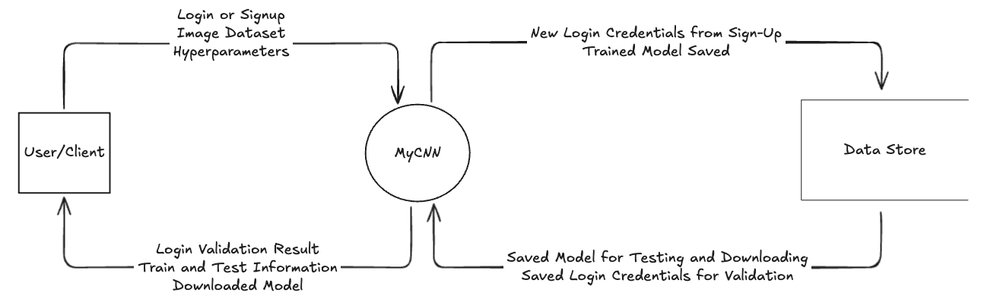

3.2 Data Flow Diagram (Level 1 Data Flow)
Illustrate how data moves through the system.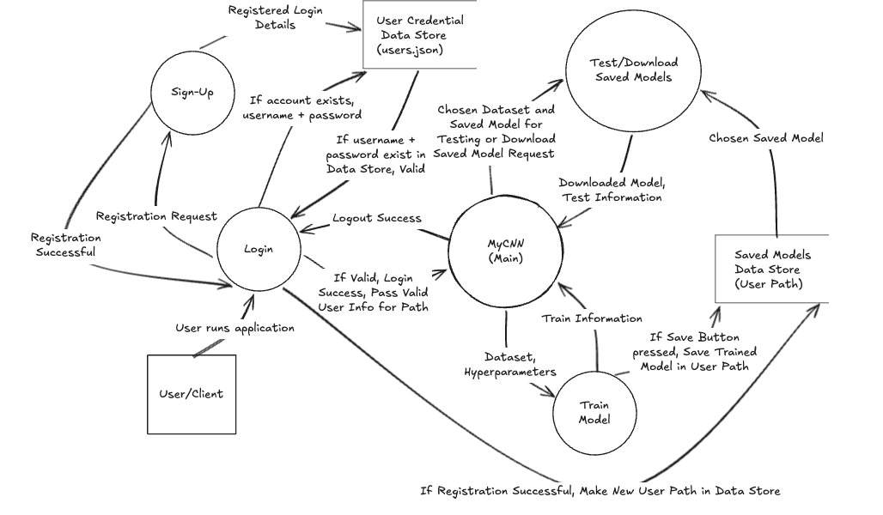

3.3 Structure Chart
Show the modular structure of the system and relationships between modules.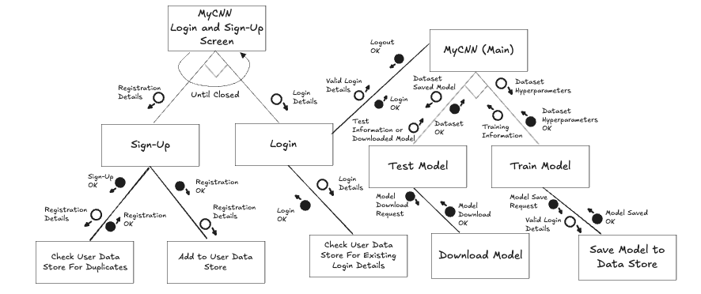

3.4 IPO Chart
Input | Process | Output
User Actions (Keyboard, Mouse) | Initialize Gradio App, tab navigation, back-end functionality | Updated UI state, back-end data and processing
Login with Username + Password | Use bcrypt to encrypt details and compare to stored data in users.json | Login result (Success or Failure) displayed, authenticated session
Valid login information | Passed to initialize user designated file path for saving models | Enable .pkl file storage of models
Registration with Username + Password | Use bcrypt to encrypt details and compare to stored data in users.json, validate for duplicates | Registration result (Success or Failure) displayed
Valid registration information | Passed to initialize new user designated file path for saving models. | Registration details encrypted with bcrypt and added to users.json
Training Dataloader (dataset iterator) | Run training loop on dataloader, train CNN model, calculate losses and other metrics and show graphs during training (from passing losses and epochs concurrently). | Real-time training progress through graphs (loss curve, confusion matrix), loss values, basic metrics (accuracy, loss) and advanced metrics after training (recall, precision, F1 score)
Training Dataset (original images), batch size | Chosen transformations/default transformations applied to dataset (preprocessing), converted into a data loader with a specified iterator made from batch size inputted. | Returns training data loader, ready for inference.
Currently stored training losses, epoch count | Training losses and epochs converted into graphical form through losses. | Returns created loss curve concurrently during training to UI helpers.
Hyperparameters (model learning rate, batch size, epochs) | Updates training configuration and passes to training loop | Updated training behavior and metrics
Post-Training Saving | Saves model as .pth into per-user folder (saved_models/{username}/model{num}.pth/) after checking valid user details | Confirmation message displayed
Saved model{num}.pth in Test/Download Tab | Retrieves and initializes model from .pth file from per-user folder path into test state | Post-test predictions
Testing Dataloader (dataset iterator) | Run testing loop on data loader, calculate loss and other metrics and processed confusion matrix after finishing testing. | Show calculated testing metrics and data, show confusion matrix.
Test Dataset (Image Data) Selected for Testing | Preprocesses new dataset, runs test loop, store all predicted labels and all true labels passing to update_confusion_matrix, calculate metrics and show graph post-testing | Real-time testing progress through graphs (loss curve, confusion matrix), loss values, basic metrics (accuracy, loss) and advanced metrics after testing (recall, precision, F1 score)
All predicted labels and all true labels | Passed predicted labels and true labels converted into graphical form. | Return calculated confusion matrix to UI helpers.
Saved model{num}.pth in Test/Download Tab Selected for Download | Retrieves and initializes model from .pth file from per-user folder into .pkl file format | Downloaded model file (.pkl)

3.5 Data Dictionary
Name | Type | Format for Display | Size | Example | Validation | Description
username | String | XX…XX | <= 32 chars | Username1 | Must be non-empty text | Stores user login name
password | String | NXX…XX | >= 8 and <= 32 chars | Password1 | Must be non-empty, alphanumeric, >= 8 chars | Stores user password
path | String | XX/XX/XX | <= 256 chars | Downloads/hymenoptera_Data | Must be valid directory path and must exist | Stores the path of the train and test dataset folders, used in validation of file structure, location and existence.
base_data_dir | String | XX/XX/XX | <= 256 chars | /Users/Name/Downloads | Must be valid absolute path and must exist | Stores the base path of the application, used to validate path location of the train and test folders to ensure security.
resolved | Path | XX/XX/XX | <= 256 chars | /Users/Name/Downloads/hymenoptera_data | Must resolve to base_data_dir and must exist | Resolute/expanded form of the user inputted path used to verify if it is in the original base.
resolved_str | String | XX/XX/XX | <= 256 chars | /Users/Name/Downloads/hymenoptera_data | Must match resolved path string | resolved converted to string to check if it is in the original directory.
train_dir | Path | XX/XX/XX | <= 256 chars | /Users/Name/Downloads/hymenoptera_data/train | Must exist and be a directory | Train directory reference created, used to check if it exists and if it is a directory.
test_dir | Path | XX/XX/XX | <= 256 chars | /Users/Name/Downloads/hymenoptera_data/test | Must exist and be a directory | Test directory reference created, used to check if it exists and if it is a directory.
train_classes | List | [XX, XX, …] | Variable | [“/hymenoptera_data/train/ants”, “/hymenoptera_data/train/bees”] | Must contain >= 2 valid directories | Stores the folders inside train_dir to get class directories through iteration and checking if it is a valid directory. Additionally used to check if it has greater than or equal to 2 classes.
test_classes | List | [XX, XX, …] | Variable | [“/hymenoptera_data/test/ants”, “/hymenoptera_data/test/bees”] | Must contain >= 2 valid directories | Stores the folders inside test_dir to get individual class directories through iteration and checking if it is a valid directory. Additionally used to check if it has greater than or equal to 2 classes.
train_class_names | List | [XX, XX, …] | Variable | [“ants”, “bees”] | Must match test_class_names | Sorted list of the train class names by iterating through the train directories. Used to check if it has the same class names as the test class names.
test_class_names | List | [XX, XX, …] | Variable | [“ants”, “bees”] | Must match train_class_names | Sorted list of the test class names by iterating through the test directories. Used to check if it has the same class names as the train class names.
class_dir | Path | XX/XX/XX | <= 256 chars | train/ants | Must be a valid directory path | Iterator used to loop through every file in the train and test folders.
images | List | [XX.jpg, XX.png] | Variable | [“img1.jpg”, “img2.png”] | Must be valid image files | Stores all the files in train_classes and test_classes from the class_dir iterator.
image_type | Boolean | True/False | 1 byte | True | Must return True for valid image | Returned variable of imghdr.what(path) which checks if True, it is an image else it is not an image, False. Overall for path security checking.
invalid_images | List | [XX, XX, …] | Variable | [“file.txt”] | Must contain >= 0 invalid files | Stores all files which are not images by iterating through images and checking with imghdr.what(path). Used to check if there are more than 0 invalid images, overall for path security.
device | device.type | XX | <= 8 chars | cuda | Must be one of {cuda, mps, cpu} | Stores the device type available in the user’s computer. Can store cuda (GPU), mps (Metal Performance Shaders for Macbook) or cpu. Device stored for training and testing purposes.
epochs | Integer | NN | 4 bytes | 10 | Must be > 0 | Stores user inputted epoch count, which dictates how many times the model loops through the training dataset.
lr | Float | N.NN | 8 bytes | 0.001 | Must be > 0 and < 1 | Stores user inputted learning rate, controls how quickly or slowly the model moves towards minimizing the loss function/how big a step the model takes when updating its weights.
train_bs | Integer | NN | 4 bytes | 32 | Must be > 0 | Stores user inputted training batch size, used to determine the number of samples processed together in one forward and backward pass of the neural network.
test_bs | Integer | NN | 4 bytes | 32 | Must be > 0 | Stores user inputted testing batch size, used to determine the number of samples processed together in one forward pass of the dataset.
train_path | String | XX/XX/XX | <= 256 chars | /train | Must exist and be a directory | Stores user inputted training folder path, used to obtain the training dataset.
test_path | String | XX/XX/XX | <= 256 chars | /test | Must exist and be a directory | Stores user inputted testing folder path, used to obtain the testing dataset.
train_transforms | torchvision.transforms.Compose | N/A | Variable | transform.Compose([…]) | Must be valid transforms object | Stores user inputted transforms for training, used to augment the dataset and convert it to a tensor, focus on understanding key relationships in images.
test_transforms | torchvision.transforms.Compose | N/A | Variable | transform.Compose([…]) | Must be valid transforms object | Stores user inputted transforms for testing, used to augment the dataset and convert it to a tensor, focus on understanding key relationships in images.
layer4 | Boolean | True/False | 1 byte | True | Must be boolean | Stores user inputted Boolean determining if layer4 in the model neural network should be frozen or not.
loss_fn | torch.nn.modules.loss.CrossEntropyLoss | N/A | Variable | CrossEntropyLoss() | Must be valid loss function | Stores the loss function used to evaluate the model’s performance.
test_loss | Float | N.NN | 8 bytes | 0.45 | Must be >= 0 | Stores the overall test loss of the model.
test_acc | Float | N.NN | 8 bytes | 0.92 | Must be > 0 and < 1 | Stores the overall test accuracy of the model.
X, y | torch.float32, torch.float64 | [NxCxHxW], [N]  N: Batch size, C: RGB Channels, H: Height, W: Width | Variable (depends on batch size and image dimensions) | X = torch.Size([32, 3, 224, 224]), y = torch.Size([32]) | Must be valid tensors; X must be float tensor of images, y must be integer/float tensor of labels | Stores the batch of images and class labels from the dataloader.
y_pred | torch.float32 | [Nxnum_classes] | Variable | torch.Size([32, 2]) | Must be float tensor, dimension must match number of classes | Stores the model’s logits, indicating its prediction of the image according to class labels.
avg_test_loss | Float | N.NN | 8 bytes | 0.38 | Must be >= 0 | Stores the average loss by dividing test_loss by the dataloader length after testing.
avg_train_acc | Float | N.NN | 8 bytes | 0.88 | Must be >0 and <1 | Stores the average accuracy by dividing test_acc by the dataloader length after testing.
param_list | List | [XX, XX, …] | Variable | [layer1.weight, layer2.bias] | Must contain trainable parameters, non-empty | Stores the parameters in the model that are unfrozen/trainable.
optimizer | torch.optim.adam.Adam | N/A | Variable | Adam(model.parameters(), lr=0.001) | Must be valid optimizer object | Stores the optimizer Adam, an algorithm used to update model weights using the gradients computed in backpropogation.
EPOCHS | Integer | NN | 4 bytes | 10 | Must be positive integer | Stores the user inputted epoch count.
epoch | Integer | NN | 4 bytes | 1 | Must be <= EPOCHS | Iterator which loops through the EPOCHS variable.
train_loss | Float | N.NN | 8 bytes | 0.32 | Must be >- 0 | Stores converted current loss variable to float by using .item()
train_acc | Float | N.NN | 8 bytes | 0.91 | Must be > 0 and < 1 | Stores the accumulated accuracy of the model’s current prediction.
avg_train_loss | Float | N.NN | 8 bytes | 0.32 | Must be > 0 | Stores the average loss by dividing train_loss by the dataloader length after testing.
avg_train_acc | Float | N.NN | 8 bytes | 0.91 | Must be > 0 and < 1 | Stores the average accuracy by dividing train_acc by the dataloader length after testing.
model | torchvision.models.resnet18 | N/A | Variable | resnet18(pretrained=True) | Must be valid model object | Stores the resnet18 model reference with its original weights, creates a new layer with .fc which can be trained on and used for training and testing.
param | torch.nn.Parameter | N/A | Variable | Parameter(torch.Tensor([…])) | Must be valid trainable parameter | Iterator which stores a trainable weight in the model. Used to unfreeze or freeze, meaning the neural network will not train or train those parameters.
default_test_transform | torchvision.transforms.Compose | N/A | Variable | Compose([Resize(224), ToTensor()]) | Must be valid transform object | Stores the default augmentations/transformations for the model. Used in case transformations are not provided by the user.
test_dataset | torchvision.datasets.ImageFolder | N/A | Variable | ImageFolder(root=’test’, transform=test_transforms) | Must be valid dataset object | Stores a PyTorch dataset from the test folder, reading images from the test directory and using test augmentations.
test_dataloader | torch.utils.data.DataLoader | N/A | Variable | Dataloader(test_dataset, batch_size=test_bs, shuffle=True) | Must be valid dataloader object | Stores samples from the test dataset, groups them into batches from test_bs, applies transforms, shuffles the dataset, and returns X, y pairs pertaining to image and class label. Used for model testing.
default_train_transform | torchvision.transforms.Compose | N/A | Variable | Compose([Resize(224), ToTensor()]) | Must be valid transform object | Stores the default augmentations/transformations for the model. Used in case transformations are not provided by the user.
train_dataset | torchvision.datasets.ImageFolder | N/A | Variable | ImageFolder(root=’train’, transform=train_transforms) | Must be valid dataset object | Stores a PyTorch dataset from the train folder, reading images from the train directory and using train augmentations.
train_dataloader | torch.utils.data.DataLoader | N/A | Variable | Dataloader(train_dataset, batch_size=train_bs, shuffle=True) | Must be valid dataloader object | Stores samples from the train dataset, groups them into batches from train_bs, applies transforms, shuffles the dataset, and returns X, y pairs pertaining to image and class label. Used for model training.

Note – This data dictionary contains variables from my early sprints, the text-based model of my application, where variables are reduced to their higher-level functionalities to provide reasoning. While this doesn’t reflect a great portion of my finished system, it is a framework of what the planned system would have been if functionality was constrained to these specific use-cases.

3.6 UML Class Diagram (if OOP)
Include a class diagram if your project uses an OOP approach.
Explain the class structure and relationships.
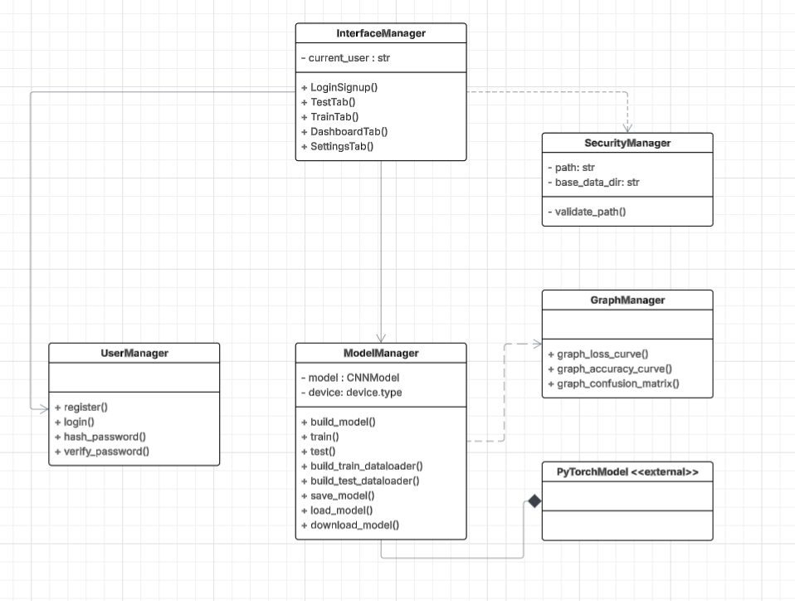
Explanation: The following UML class diagram reflects the planned architecture of the MyCNN app. While it does not explicitly follow the object-oriented paradigm due to its one-to-one relationship-based nature with not many instances, a class structure was used to exemplify clarity and tidiness of the program. This shows the basic functionalities encapsulated, from logging in, building the user interface, graphing, validating the user inputted dataset path, and systems pertaining to model building and processing of data. These are all interconnected through associations, dependencies and compositions as shown by the solid, dotted, and shaded diamond lines respectively. The interface contains associations to user and model managers as it uses these as part of its normal operation. It additionally uses security manager in a temporal use-case, as it is not centered around it greatly. Similarly, model manager uses graphing briefly for training and testing operations. Model manager additionally draws a composition from an external class called “PyTorchModel” which defines the neural network architecture, which cannot be used independently and is managed entirely by model manager.

4. Producing and Implementing

4.1 Development Process
Describe how the solution was built and implemented.
Justify the engineering techniques used, such as:
- Modular design
- Object-oriented principles
- Reuse of code
- Validation and error handling
The solution was built and implemented with a cohesive structure, where baseline features were first built and then expanded into a much larger programmatic approach, mirroring the bottom-up approach in traditional software engineering. This used a class-based structure where I would use a model handler, separate UI interface tabs, security handler, graph handler and a profile handler in separate classes to facilitate structure utilizing an OOP approach even while it does not follow the object-oriented paradigm completely. These modules could then be integrated through associations, dependencies and compositions and improved through the addition of other modules/functions in those individual classes. Reusability was achieved through generalized functions and class methods. For example, train_transforms_dataset and test_transforms_dataset share a similar structural pattern but are not duplicated code due to their distinct responsibilities. Validation and error handling was implemented throughout the system rigorously, from directory structure checks, device availability checks to user input validation to prevent runtime failures and invalid conditions.
This development process was iterative and followed an incremental approach. Initially, I would commence the development of a text-based prototype without UI to preserve functionality and baseline features, such as dataset loading, training and testing loops, and model building were stable before adding complexity and interface layers. I would then build the skeleton of the interface with the train, test, and login/signup tabs. UI functionalities such as login and signing up, encryption, downloading and saving of models were also implemented concurrently. One model explainability was added as it was built-in with PyTorch, GradCAM. As the baseline system was completed earlier than anticipated, deviating from the Gantt chart, I used additional time to expand the system with advanced features including further model explainability tools (Feature Visualisation, Activation Maps), developing an advanced analytics dashboard with pdf downloads, customizable settings, GPU and CPU analytics, and a helper chatbot powered by GPT-OSS. Strictly additional features were guided, strengthened and debugged through the help of external sources (referenced in appendices) and AI outsourcing. Throughout the progression of the project, I would utilise iterative refinement and testing to maintain stability while increasing functionality. Furthermore, this iterative refinement allowed for the solution to maintain usability, accessibility, performance, availability, security, and maintainability and alignment with software engineering best practices.

4.2 Key Features Developed
Describe the core features of the system.
Justify their inclusion.
Image Classification System (Core CNN Model)
Description: Users can train convolutional neural networks on their own uploaded datasets and hyperparameters, as well as perform inference on these models.
Justification: This is the primary objective of the system which was envisioned, enabling users to build and test their own image classifiers for various use-cases, specifically targeted towards small organisations who wish to utilise CNN models.

Model Management (Save, Load, Download, Track Models) and Analysis (View Gaphs, Generate PDF Graphs, Hardware Analytics)
Description: Users can save trained models under their username, reload them later, and manage model versions in an interactive dashboard. Additionally, users can view saved graphs and generate PDF reports in this dashboard. While in training, users can also view hardware analytics for CPU and GPU usage.
Justification: Supports long-term use, experimentation, and comparison between models. This is essential for a platform which supports a machine learning centered stance in terms of usability.

Grad-CAM Visualisation
Description: Generates a heatmap overlay showing which regions of an input image contributed most to the model’s prediction.
Justification: Improves explainability of the model’s processing, a key requirement in AI systems. This feature helps users understand why the model made a prediction, which was crucial as my target audience may not be accustomed to machine learning, as well as supporting trust by supplying transparency in models.

Feature Visualisation (Activation Map Visualisation)
Description: Creates a tiled grid image of raw activation/feature maps in a CNN model, using forward hooks to capture activation output from a certain layer during inference.
Justification: Serves as another visual representation of feature extraction by CNN models. This delves deeper into how layers progressively capture more complex patterns and provides an intuitive understanding to users.
Feature Visualisation (Gradient Ascent / Channel Visualisation)
Description: Generates images that maximally activate a neuron/channel of a CNN model, revealing what patterns the model has learned.
Justification: Serves as another visual representation of neural network internals and supports deep understanding of the CNN model. This was employed for further interpretability via users.

User-Friendly Interface (Gradio)
Description: Interactive UI for uploading images, training and testing models, viewing predictions, and generating visualisations. Additionally contains settings for customizability of preferences, music, profile picture and a specialized chatbot with text-to-speech.
Justification: Makes the system accessible to non-technical users. Enhances usability and meets the requirement for a user-centered software product

Dataset Security Handling and Login / Sign Up
Description: Rigorous dataset security testing through 20 different checks, monitoring for any invalid dataset structures or file types. Additional login and sign-up functionality for added security and checks for password strength.
Justification: Promotes and facilitates security of the application, preventing malformed or unsafe datasets from entering the system, while also safeguarding user access. This aligns with critical software engineering legislations and industry best practices dedicating data integrity and responsible system operation.

4.2.1 Back-End Engineering Contribution
Explain how back-end engineering contributed to the success and ease of use of the software, including
- Data processing
- Validation and logic
- Storage and retrieval
- Authentication (if applicable)

Data Processing: The back end automated all dataset handling including image loading, resizing, transformations, batching, shuffling, and additionally handled dataset structure verification with GPU/CPU device management. Users need only to give a dataset of the required structure, containing a train and test folder and pertaining classes inside without needing technical knowledge of vast data processing pipelines. This reduced user error and improved training stability, as well as improving the accessibility of the app through lowered training times.
Validation and Logic: The back end implemented over 20 security and validation checks, pertaining to file-type, directory structure, corrupted images, safe paths, model parameters, and error handling and exception management. These checks prevented unsafe file access and invalid configurations. This increased robustness of security and user trust, aligning with best practices.
Storage and Retrieval: The back end managed the saving of trained models in state_dicts in their own dedicated .pth file, loading these models by name, storing user-specific model directories via username and retrieving data pertaining to the model for graphing and PDF report generation. This allowed users to train multiple models, revisit previous experimentations, and reuse saved models without retraining. Additionally, users could download these models, where the backend would load the model from the .pth file as well. Storage improved workflow efficiency and the system felt professional and organized.
Authentication: The back end handled secure login and sign up, password hashing via bcrypt, strength validation, email format checking, and user-specific storage isolation. Authentication was a primary backend functionality to protect user models and the data pertaining to them. Strong password enforcement and hashing aligned with relevant security standards, preventing unauthorized access and maintaining data integrity. In addition to safe dataset loading, authentication added a professional layer of security to the system.
Overall Contribution: Back-end engineering was imperative to the success of MyCNN. This was ensured through reliability of strict validation, security through authentication and safe dataset handling, performance through model and data pipelines, usability by abstracting complex data configuration from users, and scalability using modular managers.

4.3 Screenshots of Interface
Include annotated screenshots explaining how the user interacts with the system.
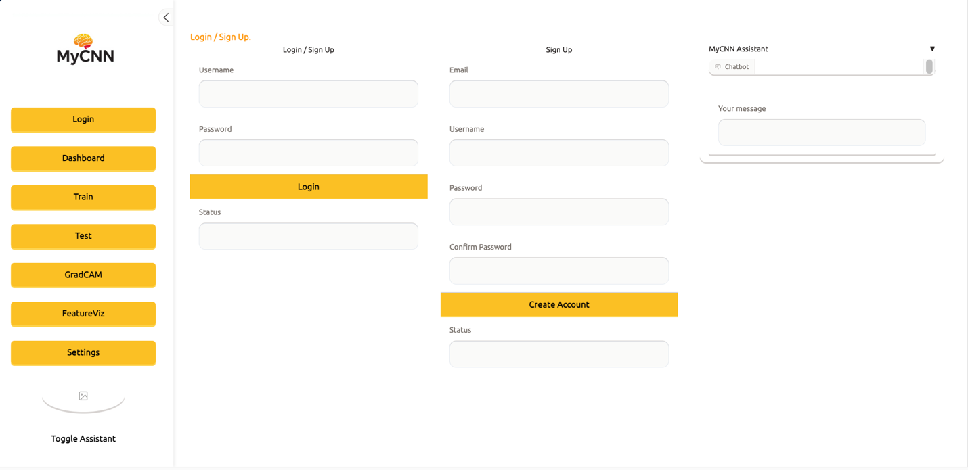
Initial Login / Sign Up Screen

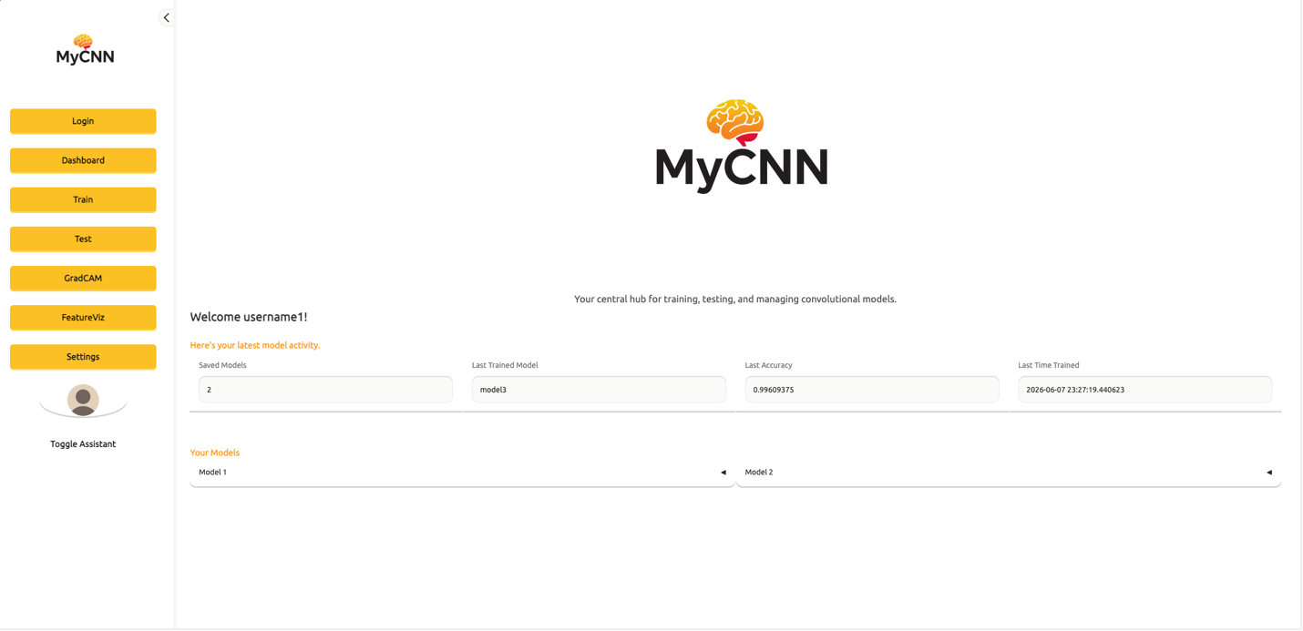
Dashboard Screen (Saved model accordion not expanded)
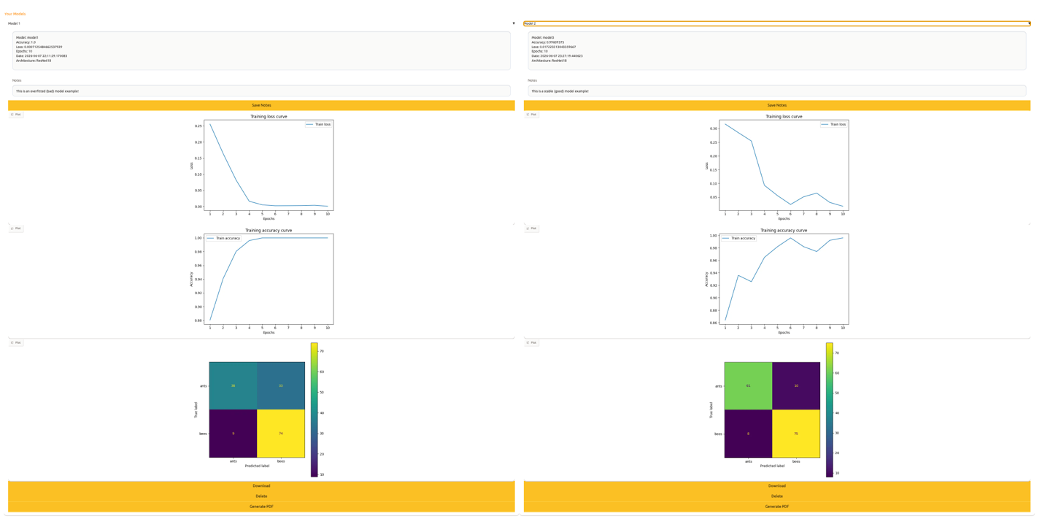
Dashboard Screen (Saved Model Accordion Expanded)

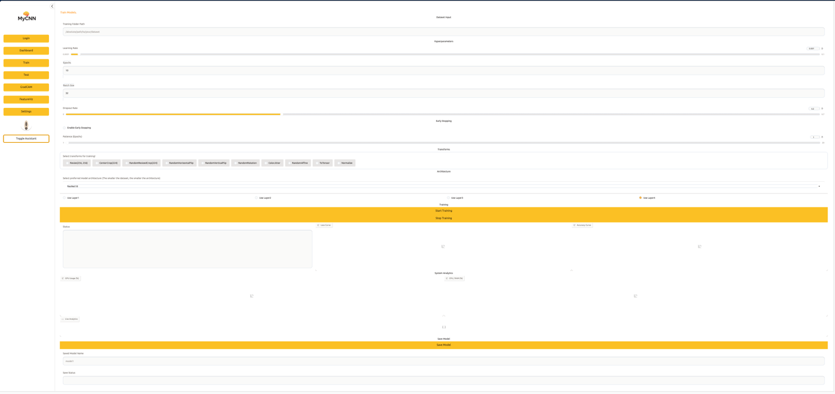
Train Tab Screen (Not trained)

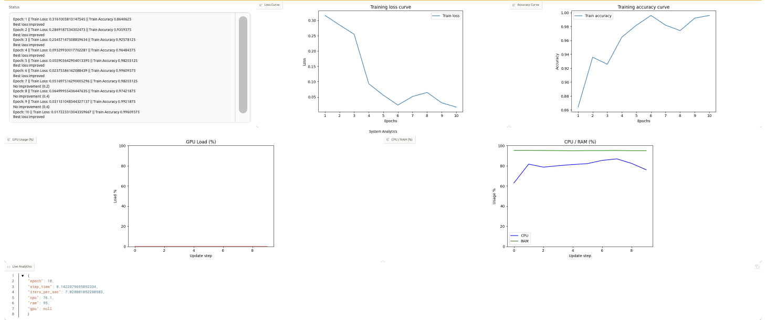
Train Tab Screen (Trained)

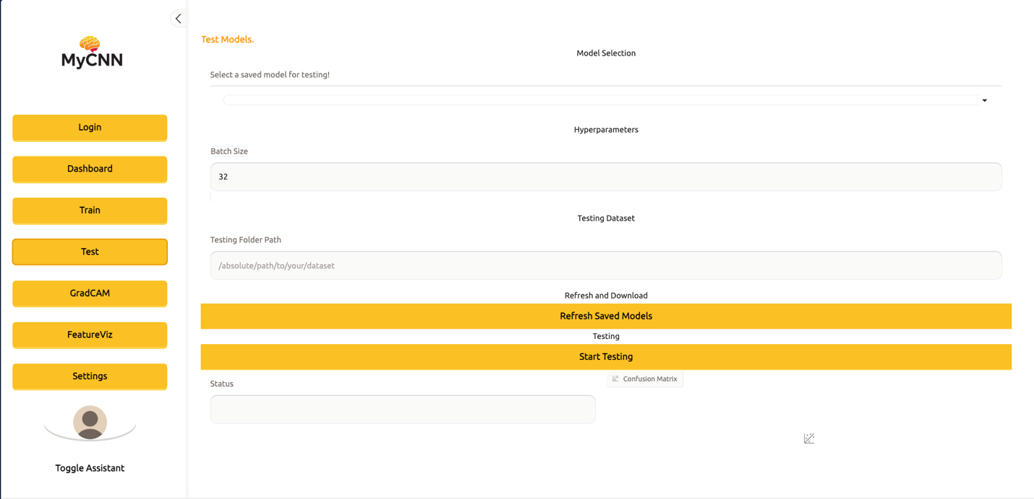
Test Tab Screen (Not Tested)

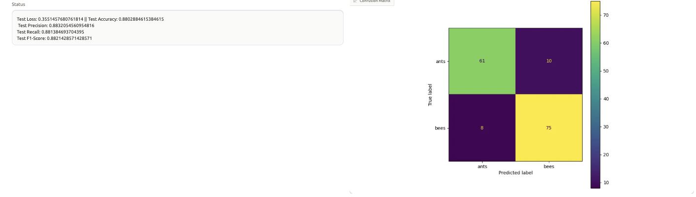
Tested Tab Screen (Tested)

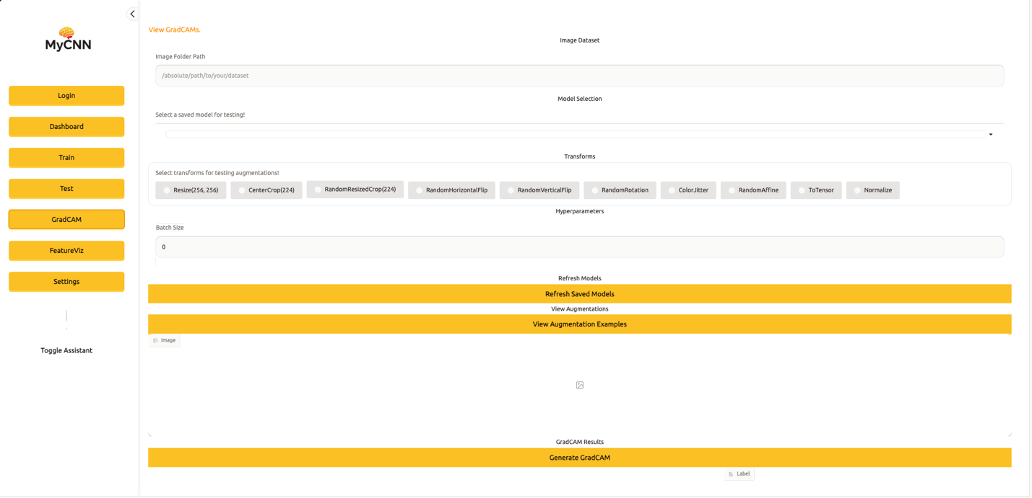
GradCAM Screen (Not used)

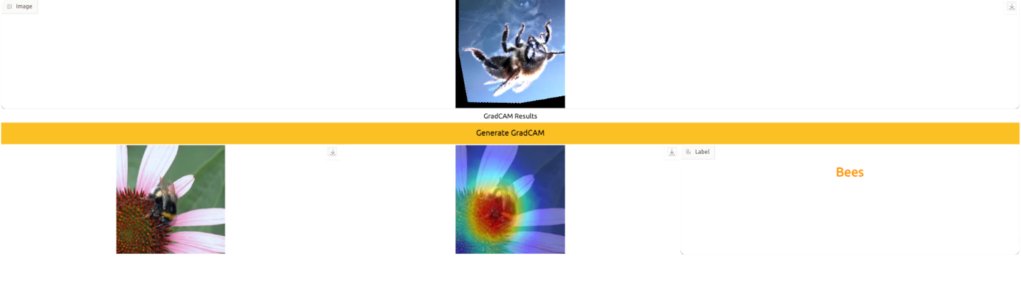
GradCAM Screen (Used)

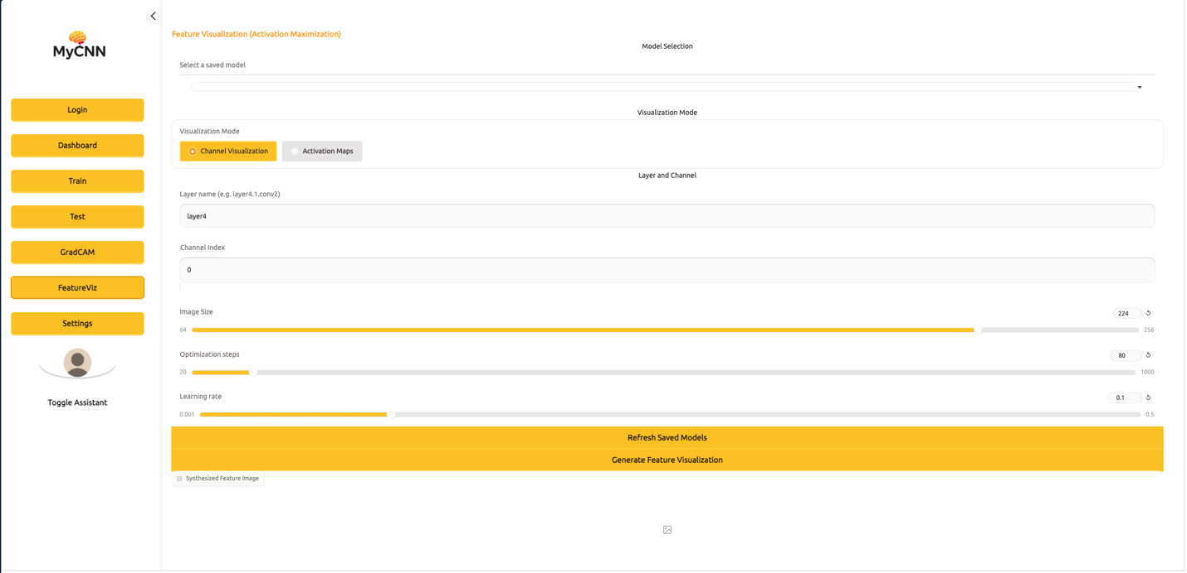
Feature Viz Screen (Channel Viz Not Used)

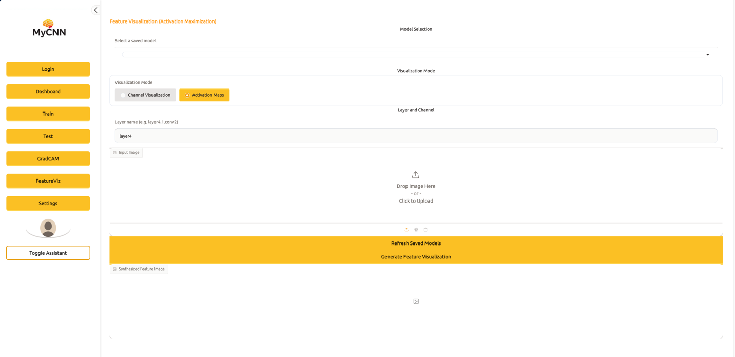
Feature Viz Screen (Activation Map Not Used)
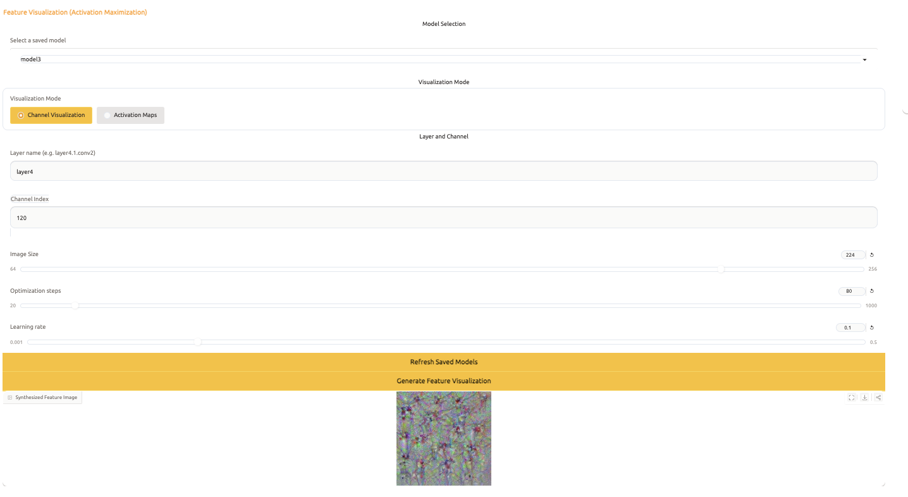
Feature Viz Screen (Channel Viz Used)

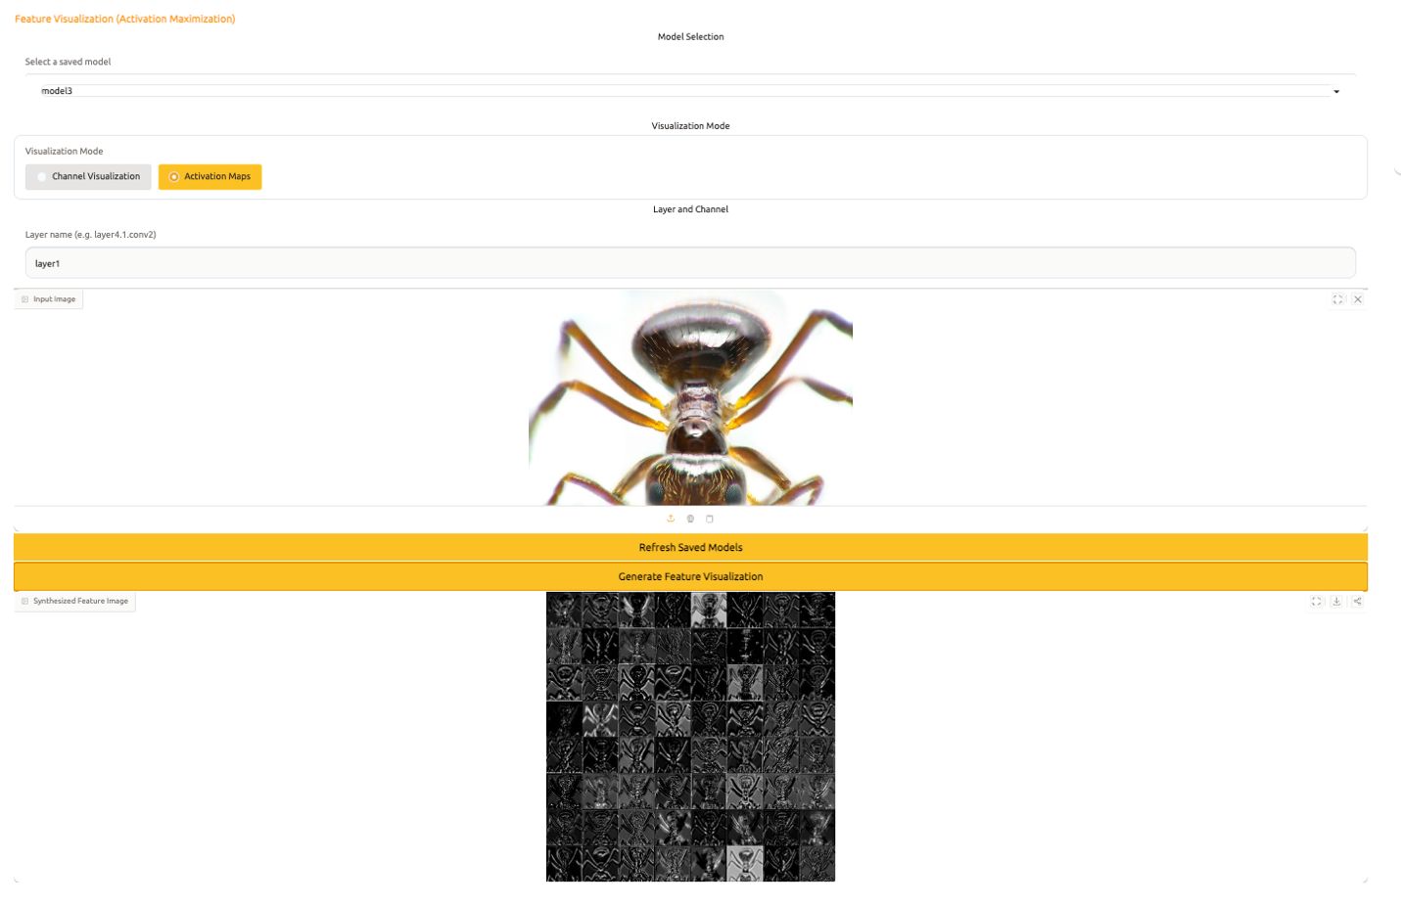
Feature Viz Screen (Activation Map Used)

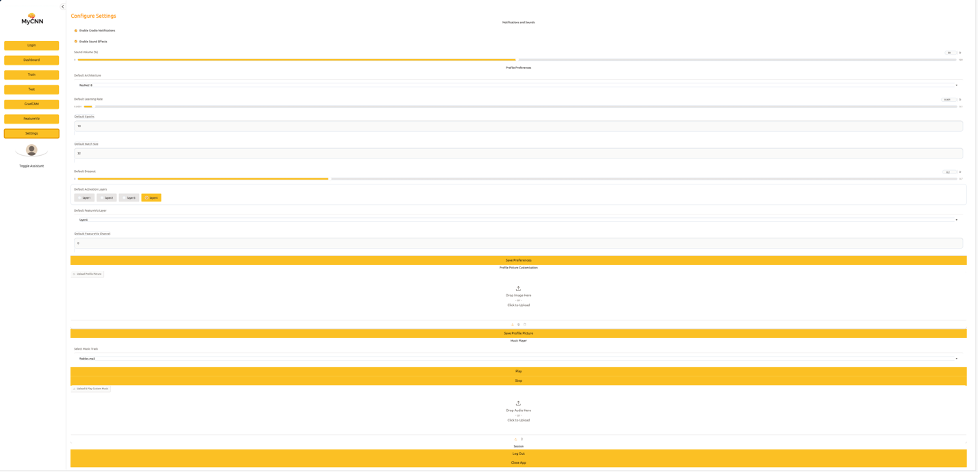
Settings Tab Screen

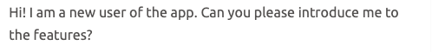
Example Chatbot Message

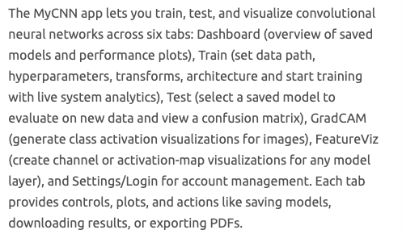
Example Chatbot Reply

4.4 Version Control Summary (Optional)
Summarise commits, iterations, or sprints if version control was used.
Sprint | Key Tasks/Commits
Main Model Functionality, Metric Calculations, Augmentations | Made a class for the Model called Model Manager, handling model training, testing, building, and augmentations.
Secure Data Loading and Preprocessing | Implemented a separate Security Manager class with basic data loading protocols, including checking the base path of the dataset, formatting, and validity of images.
Finished Graphing System and Advanced Post Training/Testing Metrics | Implemented a loss curve which would be displayed after training, which can possibly be altered to update concurrently each epoch. Additionally added advanced post-testing metrics such as precision, recall and f1 score, as well as a confusion matrix which displays the number of predictions the model correctly and incorrectly allocated. Additionally, the confusion matrix functions for any number of classes.
Gradio Training Integration and UI Pipeline | Created a copy of model handler specifically for testing user inputs to the class methods. Then, the first Gradio UI has been initialised with the relevant UI elements (buttons, text inputs, sliders, checkboxes) and coordinated with a pipeline and click functionality. This works smoothly with the yield component which retains its current loop state in printing epoch by epoch results and successfully meets performance standards being under 2 mins as well as working concurrently with security handler.
Save Model Functionality | Created the save model functionality in the model manager. Loads the user Json and checks if the user is logged in and checks if the model’s name is already stored in their saved models. If not, it creates the path where the .pth would be stored, storing the model weights in the path, and writes the path data to the Json. This appears in the train tab UI.
Testing Tab Structure | Built the full testing tab structure, with no functionality initialised except for small changes to model handler where test metrics are returned.
Created Sign Up and Login UI and relevant pipelines | Created static methods which assist in the login and sign-up pipelines. This includes load users, save users, hash password, check password.
Implemented Testing Inference | Implemented model loading from saved .pth files with user-specific names included for organization and fluidness. Added post-testing metrics and confusion matrix directly in the UI. Fixed parameter ordering issues and removed redundant code.
Download Model Functionality | First gets the username and model name. Then loads the JSON and gets the model path from the user models. Finally, loads the state_dict (model weights) and writes a .pkl file using the original model’s name and write binary.
Added Live Updating Loss and Accuracy Graphs | Modified the model handler to pass losses concurrently through yield. Additionally implemented accuracy as another metric to graph.
Added GradCAM and Augmentation Viewing | Implemented GradCAM from the PyTorch GradCAM class. This is an explainability feature which generates a heatmap showing where the model looks to prioritize its predictions. This would take in a randomly chosen image from the dataset, the model, and go through a similar forward pass as training would incur. However, we set the GradCAM on the last block of the last layer (layer4) and target the predicted class, generating a grey scale heatmap. This was then overlayed onto the original image, producing the GradCAM. Additionally, augmentation examples were implemented where transforms would be applied on a random sample of the dataset and then shown in the UI.
Added Further Functionalities (UI and Hyperparameters) | During development I would attempt to add UI based changes, including notifications, sounds, logging out and closing the app, music player and a theme changer. Themes were not supported however due to Gradio’s static nature requiring you to reload the entire app, which was difficult as I could not prompt it to do so. In the functional side of the app, additions such as more augmentations, multiple layer unfreezing, early stopping were implemented.
Added Dashboard (Model cards with plots, general info, notes, PDF download, delete model) | The dashboard was implemented containing details such as the last trained model, accuracy, model count, and the last time logged in. After adding these rudimentary features, I implemented cards for showcasing saved model plots and general info, which appeared in a grid-based accordion structure. In these accordions, users have the choice to download the model, download a PDF report made from report lab, or delete the saved model.
Implemented Feature Visualization (Activation Maximization / Channel Visualization) | This feature reveals specific texture patterns in each convolution channel / neuron of a CNN. This targets the specific layer, captures the activation tensor produced by that layer by running a forward pass using a hook, maximizes this activation and regularizes utilizing L2 (keeps pixels from exploding) and Total Variation regularization (smooths noise). Gaussian blur was added to remove high-frequency noise. Finally, this would be normalized from 0 – 255 for PIL and returned. Advanced methods for gaussian blur, and overall activation maximization were assisted by these links:  https://www.codegenes.net/blog/gaussian-blur-pytorch/  https://www.codegenes.net/blog/activation-maximization-pytorch/  (PyTorch has an inbuilt gaussian blur method as seen in the link, however I implemented my own for dynamic kernel sizes. This controlled how blurred the image was.)
Implemented Feature Visualization 2 (Activation Mapping) | This explainability feature shows what features a channel/filter in a chosen layer detects and how they respond. Each channel may detect edges, textures, or other features depending on the dataset. This works similarly, creating a hook function to extract the raw activation tensor from the layer and return to activation grid. We then normalize each channel from 0 to 1 convert to NumPy and insert into an empty grid. This shows what each filter detected in the chosen layer. Inspiration was also taken from this link:  https://gcerar.github.io/posts/2025-05-06-feature-maps/index.html
Implemented User Parameter Preferences, Profile Pictures, CSS | Users set preferences when they log in and this required a new class, Profile Manager. Profile pictures and CSS styling were also added, where the image path would be passed in and stored in static, depicted in the global profile pic in main.py. CSS styling was used to make the profile picture circular as well as style the rest of the UI.
Implemented LLM Chat Assistant with TTS | A chat assistant was implemented, specializing in explaining functionalities and components, built from GPT-OSS from Groq. The assistant was created through a separate UI handler which builds the UI, responds and uses text to speech from GTTS to do so. Additionally, Groq required a structured chat history containing only role (who is speaking) and content (the text of the message), which used clean_history to strip other relevant metadata.
Commenting of Code, Code Optimizations, Error Handling | Added optimizations, error handling and comments. Included: try-except blocks, list comprehensions, doc-strings.

5. Testing and Evaluation

5.1 Testing Methods Used
Describe testing approaches, such as:
- Unit testing
- Integration testing
- User testing
Explain how testing results were used to improve performance, efficiency, or reliability.
As I used the Agile methodology, each sprint/feature that was added to MyCNN was complemented with additional alpha and integration testing within the current system to detect any invalidities in the features.
This testing strategy included these critical methods:
- Alpha Testing: Testing conducted internally by developers during the early stages of development. This was used to identify bugs, performance concerns, and other prevailing issues before more rigorous testing was incurred, directly influencing the greater efficiency and reliability of the system.
- Integration Testing: Testing conducted on combined modules or methods, which was used to verify communication between these methods/classes, influencing the connectedness of base functions in the system.
- Black-Box Testing: Testing conducted without knowing internal logic, focusing on purely inputs and expected outputs. This method was used to verify that features behaved correctly from a user perspective, ensuring that valid inputs produced expected outputs and invalid inputs shifted to triggering error handling.
- Acceptance Testing: Testing conducted before the final deployment of the application, ensuring the satisfaction of project requirements and usage. This was used as a final verification in MyCNN.
These testing methods were chosen in relation to the Agile framework, where alpha testing would be conducted on each new feature added and integration testing would be conducted to verify their functionality with other features accordingly. Black-box testing would be utilised mostly around the authentication component of the project, as well as around completing the user-input portions of the project process. Finally, acceptance testing serves as a final testing method verifying the overall performance, efficiency and reliability of the application as a last resort, mitigating errors that were possibly not caught early on in alpha and integration testing, as well as serving as the overall requirement satisfaction brief. Overall, these testing results present themselves highly in the overall production of the application in relation to the software development life cycle.

5.2 Test Cases and Results
Test ID | Description | Expected Result | Actual Result | Pass/Fail
ALP01 | Training Pipeline Stress Test | No crash, UI remains responsive | Matches with Expected Result | Pass
ALP02 | Invalid Hyperparameters Crash Test in Training / Testing / GradCAM | System handles error by giving an error message notification | Matches with Expected Result | Pass
ALP03 | Empty Dataset / Invalid Dataset Folder in Training / Testing / GradCAM | Error message by giving notification, no crash | Matches with Expected Result | Pass
ALP04 | Invalid Layer Name, Channel Index in Feature Viz / Activation Map or no image supplied | Select non-existent layer / channel index error message given by notification, don’t supply image in activation maps, no crash | Matches with Expected Result | Pass
ALP05 | Extremely Large Dataset supplied in Training | Proceeds with training normally with the same behavior as the provided dataset. | Attempts to proceed with training but fails to continue and results in a performance bottleneck due to incredible size. | Fail
ALP06 | Rapid Tab Switching / Button Pressing | UI does not freeze or break, proceeds smoothly. | Matches with Expected Result | Pass
ALP07 | Spam Requesting Assistant | Assistant proceeds with requests by stopping current one and then starting new one. If it persists, expect a rate-limit feature from Groq or the UI. | Matches with Expected Result | Pass
INT01 | Login -> Dashboard Integration | Successful login loads correct user model list | Matches with Expected Result | Pass
INT02 | UI -> Training Pipeline -> Model Manager + Graph Manager + Security Manager | Clicking train model triggers the backend training pipeline, showing proper graphs, analytics, and training epoch info. Additionally validates whether datasets are trustworthy. Stop training button triggers the request stop pipeline smoothly. | Matches with Expected Result | Pass
INT03 | UI -> Testing Pipeline -> Model Manager + Graph Manager | Clicking test model triggers the backend testing pipeline with proper model loading, showing confusion matrix and testing info. | Matches with Expected Result | Pass
INT04 | UI -> Model Manager -> GradCAM | Model is passed correctly for GradCAM, proceeds with GradCAM computation properly. | Matches with Expected Result | Pass
INT05 | UI -> Model Manager -> Feature Viz -> Channel Viz | Selected layer is extracted correctly, channel index and other hyperparameters support the channel visualization pipeline. | Matches with Expected Result | Pass
INT06 | UI -> Model Manager -> Feature Viz -> Activation Map | Selected image loaded correctly into pipeline, runs without interference. | Matches with Expected Result | Pass
INT07 | UI -> Settings | Selected settings / preferences update in users.json and hold for future logins (excluding music). | Matches with Expected Result | Pass
INT08 | UI -> Assistant | Assistant detects current tab which user is on and responds correctly to appropriate user input. Does not time out. | Matches with Expected Result | Pass
BBX01 | Valid Signup | Gradio notification sends valid sign-up notification, valid message added to textbox, data is added to users.json | Matches with Expected Result | Pass
BBX02 | Invalid Signup | Gradio notification sends invalid sign-up notification, notes where the user is incorrect (password not strong, fields empty) | Matches with Expected Result | Pass
BBX03 | Valid Login | Gradio notification sends valid login notification, valid message added to textbox. User redirected to dashboard. | Matches with Expected Result | Pass
BBX04 | Invalid Login | Gradio notification sends invalid login notification, invalid message added to textbox. User remains in login page. | Matches with Expected Result | Pass
BBX05 | Valid Dataset for Training / Testing / GradCAM | Training, testing and GradCAM pipeline proceed as expected with no error message given. | Matches with Expected Result | Pass
BBX06 | Invalid Dataset for Training / Testing / GradCAM | Gradio notification sends invalid warning, Security Manager sends details on which part of the dataset is conflicting. If dataset does not match with model instance in testing or GradCAM, different error message given. | Matches with Expected Result | Pass
BBX07 | Invalid Hyperparameters given in Training, Channel Visualization, GradCAM | Gradio notification sends invalid warning, sends details on which part of the hyperparameters given is conflicting. | Matches with Expected Result | Pass
BBX08 | User attempt to save existing model name or download PDF without testing | Notification given to user regarding model name and PDF download without testing. Clear instructions. | Matches with Expected Result | Pass
BBX09 | Valid Activation Map Generation | Activation map pipeline proceeds as expected with a valid message. | Matches with Expected Result | Pass
ACC01 | Full Login Workflow | Final verification of login working correctly. Mild error where login would show error message regarding tabs for some reason. | Matches with Expected Result | Pass
ACC02 | Full Training Workflow | Final verification of training working correctly with no stopping or errors. | Matches with Expected Result | Pass
ACC03 | Full Testing Workflow | Final verification of testing working correctly with no stopping or errors. | Matches with Expected Result | Pass
ACC04 | Full GradCAM Workflow | Final verification of GradCAM working correctly with no stopping or errors. | Matches with Expected Result | Pass
ACC05 | Full Feature Viz Workflow | Final verification of Feature Viz (Channel and Activation Map visualizations) working correctly with no stopping or errors. | Matches with Expected Result | Pass
ACC06 | Full Settings Workflow | Final verification of user settings (preferences, music, profile picture) working correctly with no stopping or errors. | Matches with Expected Result | Pass
ACC07 | Full Assistant Workflow | Final verification of the assistant chatbot working correctly with no stopping or errors. | Matches with Expected Result | Pass
ACC08 | Overall UI and Requirement Satisfaction Brief | Maximized usability, accessibility, performance, availability, security, and maintainability of the application. | Matches with Expected Result | Pass

5.3 Evaluation Against Requirements
Evaluate how effectively the solution meets the identified functional and non-functional requirements.
Overall, the solution effectively meets the identified functional and non-functional requirements while extending itself towards greater functionality, including model explainability features and quality of life updates for users:
- Custom Training and Testing of Models: Users can access separate tabs for training and inference as well as configure hyperparameters and view pertaining metrics. The system fully satisfies this, where testing confirmed that differing datasets (Shoes and Hymenoptera) and hyperparameters produced this functionality.
- Save and Download Models: Users can save models after training and access the dashboard to view options for downloading their model in a .pkl format, where model integrity is preserved through saving and loading, indicating strong reliability.
- Instructions and UI: Chatbot and Gradio interface support the need for accessible instructions, with TTS and prebuilt UI components. First-time users from peer-testing could navigate the system without external documentation, demonstrating strong usability.
- Performance and Ease: Model training and testing take less than 5 mins on the provided training data (hymenoptera and shoes), utilises tab-based structure with fluid UI and transitions. No performance bottlenecks are observed in the sample datasets (Hymenoptera and Shoes), facilitating the performance target.
- Security and Reliability: Login and Signup functionalities implemented, only users who have permissions can access their personal dashboard. Utilises validation algorithms in login to enforce strong passwords. Uses bcrypt to hash passwords with the BlowFish cipher and prevents invalid/malformed dataset injection. System functionalities are static and do not incur any errors, prioritizing reliability.
- Maintainability: Codebase designed with designated file structure which can be easily expanded or modified based on new updates of PyTorch or other libraries. New features such as explainability tools were integrated without major changes to the rest of the codebase, which demonstrated strong maintainability.
The above implementations greatly influence the overall success of the project, facilitating the basic-level functionality of the planned program, a high level of user experience through defined performance and security measures, and the potential to expand towards greater use-cases through its optimized file structure and maintainability. Minor improvements could include broader dataset support to avoid performance bottlenecks but do not coincide with the original functional and non-functional purposes.

5.4 Improvements and Future Development
Outline your project’s limitations.
Explain realistic future enhancements.
- Expanded Model Explainability: Other model explainability features other than GradCAM, Channel Visualization and Activation Maps could include Class Visualization or other features to support a more sophisticated application.
- UI Improvements: The UI could be improved with more strict CSS rules and applications, currently Gradio has many limitations for customization even as it is specialized for ML use-cases. This could’ve also meant the implementation of another framework such as Flask or HTML/CSS/JavaScript with Tailwind CSS due to its optimized performance.
- Training Improvements: The application could be improved in terms of external datasets. Training takes a prolonged amount of time for larger datasets if a user is using a CPU (This project used for testing purposes), which was expected but may also be due to external factors. Due to this, I could’ve tested the model on Google Colab using the same device presets and monitoring performance for constraints. This could have been due to Gradio’s implied use-case being model demos and not full training pipelines.

5.4 Evaluation of Social, Ethical and Communication Issues
Evaluate your project in terms of social, ethical and legal issues.
- Social Issues: MyCNN targets key social issues regarding accessibility, usability and user confidence. This project aims to provide an accessible platform for industry professionals regardless of coding or machine learning experience to train their own CNN models. This directly improves access and equality, enabling smaller firms without technical expertise to utilise AI tools. The inclusion of a UI chatbot with text-based assistance and text to speech directly improves user confidence and reduces the barrier to machine learning implications. The system also mitigates social risks such as such as confusion or misuse through implementing data validation and clean, understandable error messages. Overall, MyCNN is highly effective against social issues, supporting non-technical users and and providing transparency of model processing through features such as GradCAM and Feature Visualisation, supporting overall user experience and optimism.
- Ethical Issues: Considerations of ethical issues in MyCNN include prioritizing the privacy, fairness, transparency and responsible use of AI. The system uses bcrypt hashing to protect user credentials, ensuring that sensitive information is not stored in plain text, demonstrating strong ethical handling of intrinsic data. The project also implements 20 different validation checks for user-inputted datasets, ensuring that sensitive information is not stored in plaintext and rather in an encrypted format. This reduces the risk of bias, corrupted or harmful data being utilised to train models, which can potentially lead to more worrying ramifications. Explainability features such as GradCAM and feature visualisation promote algorithmic transparency, as users are then informed of how their models function, aligning with ethical AI principles and development. Overall, MyCNN effectively promotes the verse of ethical issues, through the prioritisation of privacy, fairness, transparency, and responsible data handling.
- Legal Issues: Key delegations of legal issues in MyCNN include data protection, copyright and secure storage of data. The system ensures that user models cannot be accessed by unauthorized users through its per-user folder structure and JSON file data storage, which heavily promotes data protection and the secure storage of data, aligning with legal expectations around data confidentiality and access controls. The use of bcrypt hashing prevents information being stored in a reversible format and prevents invalid file types and datasets from being loaded, reducing the risk of executing malicious files or violating data handling regulations outlined by key acts such as the Privacy Act 1988. Contrastingly, MyCNN implements open-source datasets and promotes custom datasets, as well as promoting libraries such as PyTorch, Gradio and Scikit-Learn to prevent legal difficulties within the verse of copyright. Overall, MyCNN promotes strong legal compliance through secure data handling, controlled access, and safe file validation, demonstrating a highly effective approach to resolving legislative complications.

6. Feedback, Security and Reflection

6.1 Summary of Client or Peer Feedback
Summarise feedback received and explain how it influenced development.
You could collect a ‘PMI’ (Plus, Minus, Implication) table from at least three different people after testing, or record and summarise an interview with at least three three people who test the software.
People | Plus | Minus | Implication
Levin Shao | Very excellent and well-made app with lots of features and extremely useful tools, I would use this if it ever launched. | Might be a bit too confusing for first time users but luckily the AI is there, results may possibly be malformed from the AI, but I have not seen so. | Excellent, takes a very high skill level to make this but can be even better with more effort! I absolutely love the AI; it provides excellent responses and is also very friendly.
Victor Guo | Well programmed and robust app, includes many security measures which ensure application does not corrupt. | This may be a personal thing, but I do not know of a use case for this. Also, I would have preferred a separate login and register screen. | Overall, MyCNN is well made with useful features, and helpful tutorials, but improvements can be made to the UI.
Shawn Fan | Clean interface, nice animations, feature-packed, and very advanced. | Very complicated and doesn’t specifically provide a tutorial on how to use it, also this seems quite niche and not very useful for a lot of people, when there are many more bigger alternatives. | Tutorial and description on how to use it, what it’s for, and what it does.
According to the received inquiries, MyCNN reflects a highly specialised approach to software development, where the variety of features strengthen its compulsive identity as an application in the verse of machine learning. While it was specifically stated in the requirements definition that the application would be implemented for smaller businesses who cannot retain their own CNN tools, using industry standard and do not have specialized machine learning abilities, some interviewees reflected how the use-case of the app may not sufficiently match with bigger alternatives. To resolve this criticism, key changes made in the development process included the implementation of GradCAM and Feature Visualisation to reflect an advanced system with greater explainability than most industry standard applications, including Google Teachable Machine and Hugging Face Autotrain. Regarding other pertaining conflicts, such as instructions and UI, I implemented an AI chatbot to support adaptability of varying questions of the application due to its advanced nature, as well as use the Gradio UI and CSS to design to a higher standard.

6.2 Secure Software Design and Data Handling
Evaluate the approach undertaken to safely and securely collect, use, and store data.
Your evaluation should address:
- Secure coding practices applied during development
- Input validation and error handling
- Data storage and protection methods
- The impact of secure software design on user trust, data integrity, and system reliability
- Secure code practices applied:
The development of the system utilised secure-coding principles such as security and privacy by design to minimise the number of vulnerabilities present in the system and ensure safe operation. Defensive programming techniques were applied throughout the codebase, including the strict control of file paths, as well as the use of consistent try and except statements to retain security in all areas of the program. Well-maintained, up-to-date libraries were also utilised for critical operations such as authentication and dataset preprocessing and model training. An environment variable was also designated for the Groq API, where secrets were not revealed to protect credentials and configuration data. Regular code reviews and iterative testing through methods such as alpha, beta, and black-box testing ensured insecure patterns were identified early, reducing the likelihood of vulnerabilities entering the program. These practices communally supported the confidentiality, integrity and availability across the system.
- Input validation and error handling:
Robust input validation was utilised for the encompassing system, where features such as hyperparameters, datasets, and other file uploads involving the sensitive transmission of data were handled to a high degree. This involved the dataset-upload pipeline including 20 distinct validation checks, detecting corrupted images, invalid directory structures, unsupported file types and unsafe paths, preventing malformed or malicious data form entering the training pipeline. Error handling was implemented consistently and safety, where exceptions were caught and converted into user-friendly error messages instead of leaking sensitive information, which attackers could exploit for further malicious activity. By sanitizing input and containing errors, the system maintained predictable behavior under misuse, improving security and user experience.
- Data storage and protection methods:
User data were stored correctly and securely using bcrypt, a renowned encryption library ensuring passwords were not stored in plaintext. Similarly, email and password strength requirements reduced the risk of weak or easily compromised accounts. Uploaded datasets were also not stored and validated with strict path-sanitisation to preserve not only transparency and reliability but also to avoid unnecessary data retention and limit access to user-specific resources, where the only instance of stored material are the models and the pertaining information generated by MyCNN. Sensitive metadata was not logged, where only the last date of login and user credentials were stored for system clarity. Model files were isolated from each user through a structured folder implementation in a parent folder, preventing unauthorised access. These methods prioritised the secure data storage and protection of sensitive data, reducing exposure and maintaining protection against malicious regiments.
- Impact of secure software on user trust, data integrity, system reliability:
Overall, the implementation of the security-by-design approach directly influenced systematic user trust, data integrity and system reliability, as MyCNN handles personal data and uploaded datasets in a responsible nature. Strong authentication, safe storage, and rigorous validation processes ensured the existence of secure software intricacies in MyCNN, where users are assured their data would not be exposed. Data integrity was preserved through strict validation and sanitisation, ensuring only valid data formats entered the training pipeline. This prevented corrupted or malicious intent from crossing into the application, as errors, failures and crashes were caught to prevent unpredictable behaviour, containing and communicating clean, understandable error messages. System reliability improved significantly due to the appliance of secure software techniques, as defensive coding and exception management streamlined the development process, synthesising clarity in system operations and reliability through the implementation of safe input and error handling, maintaining stable operation.

6.3 Personal Reflection
Reflect on what you learned during the project, including
- Software engineering skills developed
- Challenges encountered and how they were overcome
- Software engineering skills developed
Key software engineering skills developed in the project included the deployment of secure, defensive user targeted applications, the enabling of UI intricacies with traditional CNN implementations made with PyTorch, and the expanded knowledge on CNN explainability. Deployment of secure, user target applications was enabled through the initial application of the Gradio library within its execution of basic text boxes, accordions and other intrinsic features, specialised for machine learning contexts, strengthened through the bcrypt library, where encryption techniques such as hashing and decrypting were developed. By developing skills in the CSS division of the project, user experience was strengthened through the cleanliness of UI through a fully custom orange-white theme, spacing and positioning which was limited by Gradio’s current UI features and animations using the external animate.css library. Additionally, CNN explainability features were developed through consistent learning in the planning and development stages, where relevant articles were utilised to strengthen understanding on GradCAM and Feature Visualisation (Class Visualisation and Activation Mapping).
- Challenges encountered and how they were overcome
Throughout the development of MyCNN, common challenges overcame were authentication and signup pipeline issues, cross-platform issues, PDF generation bugs, the constant redesign of UI to make complex ML concepts accessible to users, and prevailing issues in model explainability features. The authentication and sign-up pipeline demanded new learning of standard hashing, validation and restructuring to ensure secure and reliable account creation. Cross-platform problems within file paths and permissions were solved by creating a universal structure for directories in varying environments. PDF generation often broke due to missing assets and library limitations, which I resolved by switching libraries from FPDF to ReportLab, which supported further customization. The UI took multiple iterations to suit the intuitive nature of ML concepts, leading me to utilise built-in themes first but then shifting to custom CSS. Explainability features such as Grad-CAM required further understanding into CNN functionality, deep debugging and iterative refinement to produce accurate visualisations. Most importantly however, the training pipeline served as the most intrinsic challenge of the project, where iterative improvements were made to training, yielding errors such as tensor shape mismatches, instability from live graphs, dataset-model mismatch errors, and critical performance errors such as freezing and crashing due to incredulous dataset sizes, which was a challenge which was briefly overcome through the use of smaller dataset sizes instead, not a fully overcame challenge but could be improved.

7. Appendices
- Full Gantt Chart
- Complete Data Dictionary
- Full Test Logs
- Raw Feedback Notes
- Exemplar Code Snippets

7.1 Full Gantt Chart
Do on the train

7.2 Complete Data Dictionary
- Ask sir if it needs to reflect the completed system

7.3 Full Test Logs
- 5.2

7.4 Raw Feedback Notes
- 6.1

7.5 Exemplar Code Snippets
- Shown Below:

